

Cyber Resilience
Assessment S1: Cyber Resilience Plan
Module Coordinator: Ian Wills
Marker: Ian Wills

Date of submission: 31/07/2024
Number of words without headers: 4,987
Number of words with headers: 5,333

Introduction:
In today’s digital era, it is of massive importance for medium-sized companies such as Teletainment to invest in cyber security and cyber resilience. This incident highlighted vulnerabilities, especially after a ransomware attack that wiped out large sections of the company's infrastructure. The core of this report is to ensure the cyber resilience plan properly aligns with the industry's best practices and compliance frameworks, ensuring Teletainment thrives in the competitive landscape of media and entertainment.
The company has five divisions – a central administrative division and four operating divisions. The central admin division is the HQ in London and the other four are development, entertainment operation services, storage and distribution and sales and marketing. These all play a crucial role in delivering T-Box services and entertainment packages.
My task as a member of the Cyber Security Team in London is to assess the cyber resilience of Teletainment by identifying compliance frameworks, assessing current cyber resilience readiness, creating threat and risk assessments, outlining a business continuity plan, organisational roles and responsibilities, overall action plan and the key assumptions and implications of the assumptions. By completing these tasks there will be a comprehensive cyber resilience plan for Teletainment to learn from, use and implement into their business.

Compliance Framework:
Compliance frameworks play a key role in Teletainment and the way we analyse and develop strategies for cyber resilience. By sticking to these frameworks, the company meets regulatory rules, keeps up with the best cybersecurity practices and strengthens its overall cyber security.
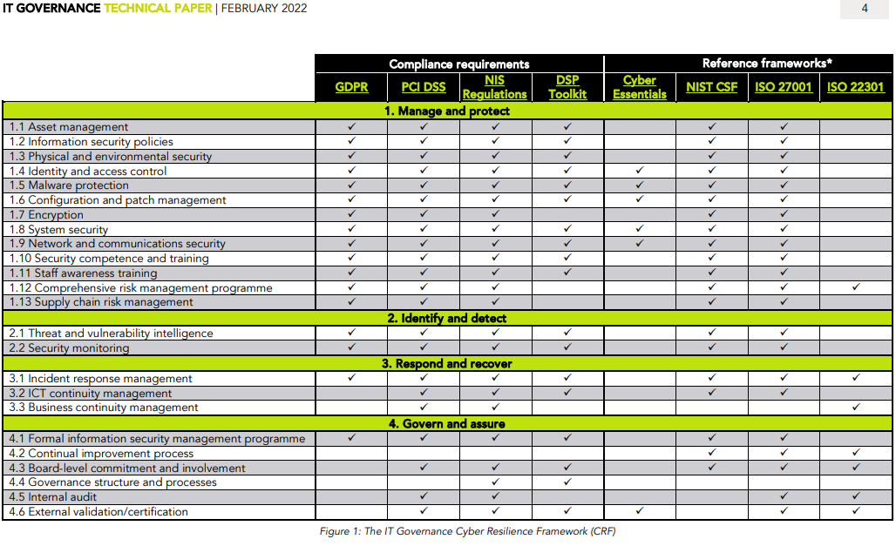(ITGovernance, 2022)

Compliance & Standards Requirements:
Teletainment must follow several key legal and regulatory standards that control cybersecurity and data protection in the areas where it does business. Some requirements may change depending on the other three locations of operating divisions of Teletainment that are not in the UK. The main frameworks include:

Telecommunications Security Act 2021
This law amends the Communications Act 2003 which adds new duties on providers of public electronic communications networks and services (Department for Digital, Culture, Media & Sport, 2021). Teletainment needs to make sure that its telecommunications have the proper protection from cyber threats. Teletainment can achieve this by having good network monitoring, response protocols, threat detection programs and processes in place so if the providers have data leaked they can mitigate the risks of it happening as well as having the appropriate responses.
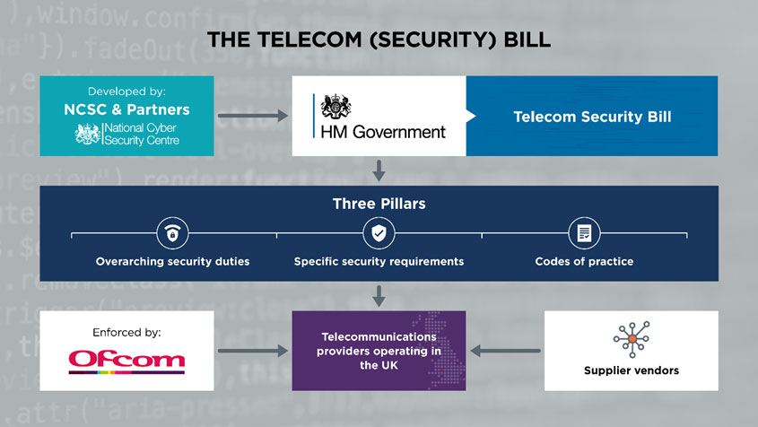(Leonardo, 2020)

Network and Information Systems Regulations 2018 (NIS)
This legislation is known as the NIS Directive and was enacted in UK law on the 10th May 2018. This law aims to achieve a high level of network systems security, and this applies to essential infrastructure services and digital services such as transport, water, energy, healthcare, online marketplaces and cloud services (IT Governance, 2016). Teletainment needs to ensure that they implement secure and robust cybersecurity measures appropriate to the risks to the company, make regular risk assessments to know what the risks are and make sure that they report any incidents that are significant no later than 72 hours after being aware of the breach. If Teletainment is non-compliant they could be fined up to £17 million which will be assessed by the authorities. These rules apply to both the OES (Operators of Essential Services) and DSPs (Digital Service Providers) and they need to decide if the incident is significant for OES and if it is substantial for DSPs (IT Governance, 2016).

Data Protection Act 2018:
The Data Protection Act 2018 is a UK law that is very similar to GDPR (General Data Protection Regulation) this outlines the procedures to collect, handle, and keep personal information to protect people's privacy. It also gives individuals the right to know what personal details are held about them and, in certain cases, the right to ask for this information to be erased (It Governance, 2018). Teletainment needs to ensure that their customer's data is protected by having robust data protection policies, that data processing is done lawfully, and that the customer's data rights are upheld (Government of UK, 2018).

General Data Protection Regulation (GDPR)
GDPR is an EU law that deals with data protection and privacy measures which require companies operating in the EU to take appropriate action for the security of their customers' data. It is expected that the companies will have security measures in place that are designed into their systems from the outset, known as Privacy by Design, and will need to be maintained throughout the life of the companies systems (NCSC, 2019).
Teletainment will need to ensure that they follow GDPR’s four aims of processing and managing personal data:
- “Manage security risks
- Protect personal data against cyberattack
- Detect security events, minimise the impact, and report within 72 hours
- Ensure data subject rights, access, rectification, and deletion of personal data”

(NCSC, 2019).

Payment Card Industry Data Security Standard (PCI DSS)
PCI DSS is an information security standard designed to reduce payment card fraud by increasing security controls around cardholder data (IT Governance, 2018). Teletainment needs to make sure that they have PCI DSS compliance and part of that is by making sure they follow the six control objectives:
- “Build and maintain a secure network
- Protect cardholder data
- Maintain a vulnerability management system
- Implement strong access control measures
- Regularly monitor and test networks
- Maintain an information security policy”

(IT Governance, 2018).
Since PCI DSS is not a law, it is enforced through contracts between merchants, banks, payment card transactions and payment brands. Each bank can fine banks for compliance violations and banks can withdraw the accepting card payments if the merchants are non-compliant. If cardholder data is leaked or stolen from Teletainment then it is also a breach of EU GDPR and has a risk of heavy penalties; 20 million euros or 4% of annual global turnover (IT Governance, 2018).

Reference frameworks:
To boost and maintain its cybersecurity posture, Teletainment should utilise these known frameworks:

Cyber Essentials
Cyber Essentials is a UK government-backed scheme designed to help protect any organisation against a range of the most common cyber-attacks. Cyber Essentials would help Teletainment reassure customers/clients that their computer systems are being worked on to secure against cyber-attacks, giving Teletainment a clear picture of their cyber security level. Some government contracts may require a Cyber Essentials certification. For Teletainment to get the Cyber Essentials certification, a self-assessment questionnaire or a readiness toolkit helps create a personal action plan that Teletainment’s answers dictate so they can meet the Cyber Essentials requirements (National Cyber Security Centre, 2023).
Cyber Essentials covers these five security controls: firewalls and routers, software updates, malware protection, access control and secure configurations. This means that it could prevent around 80% of cyber-attacks such as phishing attacks, malware, ransomware, brute force password guessing attacks, and network attacks (IT Governance, 2016a).

NIST CSF (National Institute of Standards and Technology Cyber Security Framework)
The NIST CSF is an American government cyber security framework, designed with the intent that small to large businesses use an assessment of the business risks they may encounter to make the use of the framework cost-effective (IT Governance, 2016b).
The CSF’s core functions are to Govern, Identify, Protect, Detect, Respond and Recover (NIST, 2024).
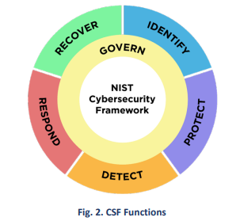(NIST, 2024)
Teletainment needs to address these functions concurrently. Govern, Identify, Protect, and Detect should all always happen continuously, and Respond and Recover should be ready to be deployed anytime a cyber security incident happens (NIST, 2024).
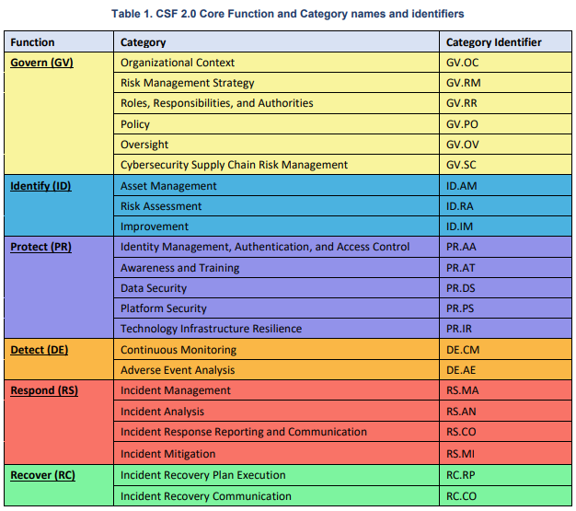(NIST, 2024b)
This is a Table showing the functions, categories, and subcategories of the CSF core. For Teletainment to have high-quality cyber resilience it would be beneficial to implement the CSF 2.0 Core functions in their systems and procedures in all Teletainment divisions and locations.

ISO 27001
ISO/IEC 27001 is the international standard for information security management. ISO 27001 provides the specification of an effective ISMS (information security management system). This framework provides organisations such as Teletainment a way to establish, implement, operate, monitor, review, maintain and continually improve their ISMS (IT Governance, 2016b).

ISO 22301
ISO 22301:2012 is an international standard for implementing a BCMS (Business Continuity Management System) enabling Teletainment to minimise business disruption and have disaster recovery in place so Teletainment can continue operating in the event of an incident (IT Governance, 2017). Implementing ISO 22301 will enable us to deal with an incident to run as “business as usual” with minimal disruption from any crisis. It will give Teletainment operational resilience, emergency preparedness, corporate governance, crisis management, disaster recovery, protection of reputation in a crisis, preparation for technology failures, reduce business interruption insurance costs and a plan for sudden loss of critical resources (Sharron, 2020).
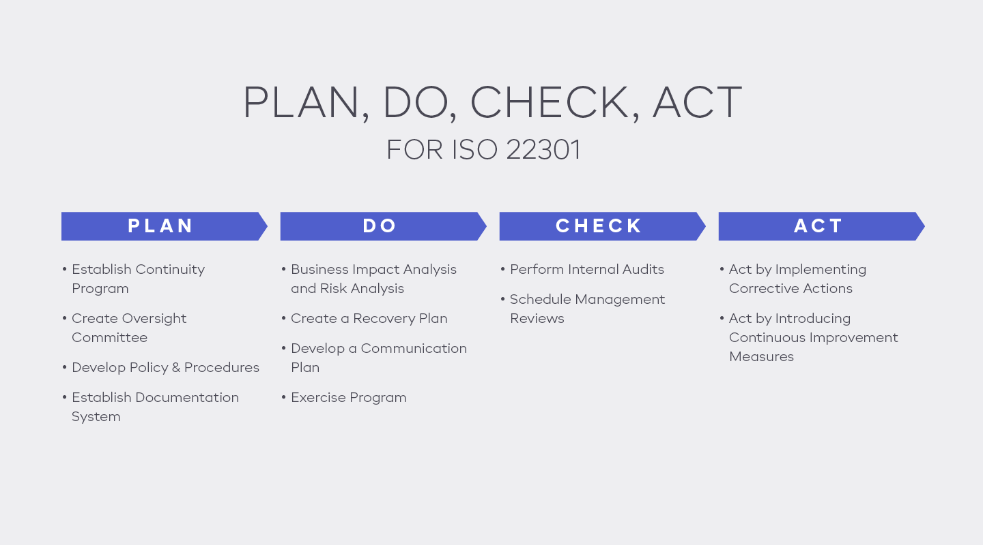(Sharron, 2020)

Current Cyber Resilience Readiness Assessment
The assessment will rate the level of cyber resilience present in Teletainment as it currently stands against vulnerabilities, including a post-cyber-incident, as well as compliance frameworks such as the GDPR, PCI DSS, NIS Regulations, and ISO 27001.

Existing Infrastructure
The company organisation breaks down into five divisions- a central administrative division and four operating divisions:
- HQ (London): Corporate, Central administration
- Development (London): T-Box product and service deployment
- Storage and Distribution (Royal Tunbridge Wells): Stock Management
- Entertainment Operation Services (London HQ, Los Angeles, CA: North and South America, Brisbane, QL: APAC): Server Operations
- Sales and marketing (London, New York, Sydney): Customer Relations
Each of these divisions has its unique infrastructure and cybersecurity challenges. These five divisions are the backbone of Teletainment’s business and to make them all interconnected and work seamlessly together increases the complexity of cybersecurity. Teletainment needs to keep a good balance between security and usability.

Previous Cyber Incident Analysis
Since Teletainment had large sections of the company’s infrastructure wiped out due to the unsuccessful decryption of a ransomware infection, highlighting the weaknesses of its cybersecurity. This section will analyse the incident to understand the vulnerabilities and causes.
How it happened: the most likely cause for which the ransomware attack was initiated would be through phishing email attacks as they are the leading cause of ransomware infections. The ransomware then spreads across the network, leading to unauthorized access and subsequent encryption of critical data (Chin, 2024).
Effect on Teletainment’s Operating Divisions: since the decryption of the ransomware failed and large sections of the company’s infrastructure had been wiped out. This will lead to data loss, service disruptions and potential reputational damage (NCSC, 2023).

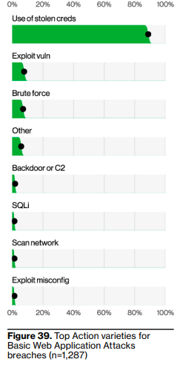
Vulnerability Analysis

Access Controls
Vulnerabilities to Teletainment could be weak access controls, such as a weak common password, no multi-factor authentication (MFA), or even giving employees too many user access rights on their computer system (NCSC, 2024).
Lack of Multi-Factor Authentication (MFA)
MFA is crucial to a secure authorisation system as without MFA it is easier for threat actors to use compromised personal credentials to gain access to Teletainments assets.
“86% of the breaches, as you can see in Figure 39, involve the use of stolen credentials” (Verizon, 2023).
(Verizon, 2023)

Insufficient User Access Reviews
Regular audits of user access rights will ensure no excessive privileges are given to employees who should not have those privileges, as if they had admin privileges there is an extremely high chance of internal misuse from employees.
“The principle of least privilege is employed, allowing only authorized accesses for users (or processes acting on behalf of users) that are necessary to accomplish assigned organizational tasks” (NIST, 2022).

Inadequate Password Management Practices
Teletainment needs to ensure that all their employees are using strong, new unique passwords across systems because using weak and reused passwords makes the systems not secure and viable to getting those credentials compromised.
“Strong, secure passwords are key to helping reduce risk to your organization and for people to protect themselves at home” (Spitzner, 2021).

Network Security Gaps

Outdated Firewall Configurations
Having a poorly configured firewall would allow unauthorised network access. A firewall monitors and controls network traffic. It is the barrier between Teletainment’s corporate network and an untrusted network that will filter the data packets on a set of security rules (Convocar, 2022) and if there are no security rules then it will not filter and make the network filter insecure.

Insufficient Network Segmentation
Network Segmentation is where a larger network is divided into smaller sub-networks with limited interconnectivity between networks. This prevents unauthorised users from accessing Teletainment’s data and intellectual property. Using network segmentation mitigates the effects and risks of ransomware on Teletainment (PacketLabs, 2021).

Data Protection Issues

Insufficient Data Encryption
Having sensitive data not encrypted can lead to a severe impact on business, leading to data breaches, loss of intellectual property, financial loss, compliance and legal consequences. To prevent insufficient cryptography, you can implement these practices: use strong encryption algorithms, implement encryption properly, validate and authenticate, regularly update security measures and conduct security testing (OWASP, 2023).

Inadequate Data Backups
Teletainment does not have reliable and frequent data backups since its infrastructure was wiped out, showing they got extended downtimes and data lost due to ransomware which if they had a reliable backup they could get up to “business as usual” a lot faster and easier. “For example, the on-site recovery system would ensure that data can be retrieved more efficiently with data backups and other means” (Sharron, 2020).

Incident Detection and Response

Lack of Real-Time Monitoring and Alerts
Teletainment needs to ensure that it has an extensive real-time monitoring and reporting system for when suspicious system or network activities happen as without it, malware can go undetected and by then it is too late as the damage will have been done.
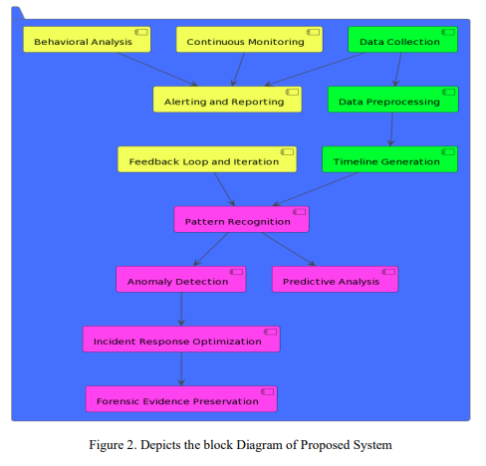 (Journal of Electrical Systems, 2023)

Absence of Incident Response Plan
Teletainment’s response plan was an unsuccessful attempt to decrypt essential services, which is not a documented incident response plan. It then led to the company’s infrastructure being wiped out, which is an ineffective way of handling cyber incidents. Teletainment needs to implement an incident response process such as the NIST IR (Incident Response) life cycle. This has four phases: Preparation, Detection & Analysis, Containment Eradication & Recovery, and Post-incident Activity (Cichonski et al., 2012).
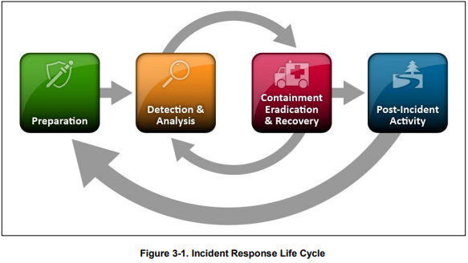
(Cichonski et al., 2012)

Lack of Employee Training

No concurrent Employee Cyber Security Training
It is paramount that Teletainment invest in cybersecurity training for their employees, because if they do not get appropriate training, they will fall for phishing and social engineering scams. Security awareness and staff training will greatly decrease the risks of a breach happening: reducing human error, increasing commitment to ISMS and improving audit results (IT Governance, 2018b).
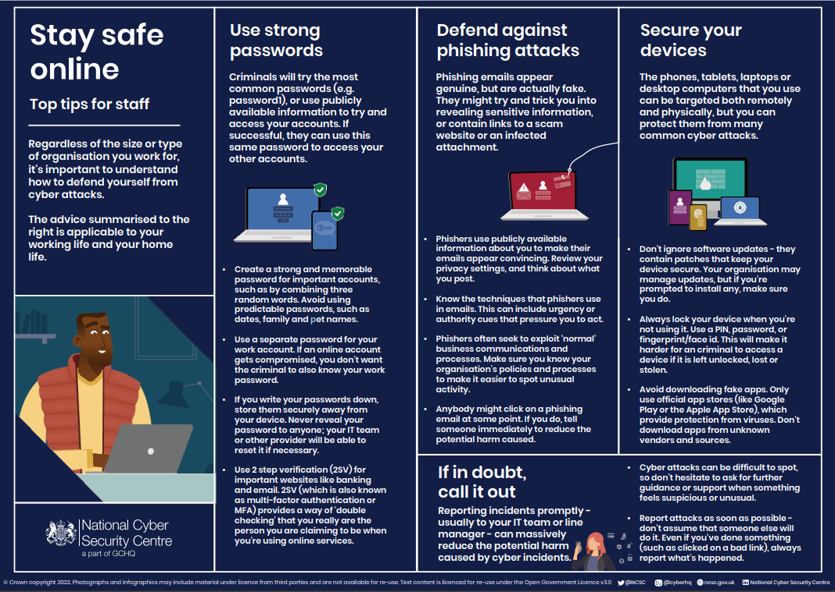 (NCSC, 2021)

Absence of simulated Cyber Attack drills
Simulated attack drills are needed to make sure employees are ready and prepared for a real incident. Teletainment can use NCSCs Exercise in a Box which is an online tool that provides exercises for companies to test and practice their response to a cyber-attack. There are three types of exercises included: Micro, Tabletop and Simulation. Exercise in a Box is developed specifically for medium-sized enterprises and is free to use so no overhead costs for Teletainment (NCSC, 2020).

Gap Analysis
This gap analysis is to make a clear comparison between the current cyber resilience practices of Teletainment and the requirements of relevant compliance frameworks which will show areas that need improvement and form grounds for the development of effective strategies for achieving good cyber resilience in the future.

Baseline Definition

PCI DSS
The PCI DSS is a set of standards for protecting credit card information. Teletainment needs to ensure that they protect card information and card processing and have a solid vulnerability management system (IT Governance, 2018).

NIS Regulations
The NIS regulations ensure the security of a network and information systems are more secure. This includes managing and securing critical sectors, network infrastructures, excellent risk management and incident reporting (IT Governance, 2016).

ISO 27001 (Information Security Management)
ISO 27001 is the standard for ISMS’s focusing on managing confidential company information and ensures that integrity, availability and confidentiality are maintained (IT Governance, 2016b).

ISO 22301 (Business Continuity Management)
ISO 22301 establishes a business continuity management system. Teletainment needs to ensure their business continues as usual after disruptions by securing critical processes and having robust recovery strategies (IT Governance, 2017).

Identified Gaps

Network Security
Current: Teletainment most likely only has basic antivirus and firewalls, and I assume it lacks network monitoring and intrusion detection and prevention systems.
Comparison: Teletainments security measures on their network are not up to PCI DSS and NIS regulations standards, and there is poor real-time threat detection and security coverage.
Gap: Lack of threat monitoring and detection tools and poor network segmentation.
Next Steps: Implement network segmentation and intrusion detection and prevention systems.

Incident Detection and Response
Current: Teletainments incident response plans are flawed and only focus on reactive measures. There are no defined roles, communication strategies and prevention techniques.
Comparison: NIS regulations and ISO 27001 are used to make a proactive structured incident response framework.
Gap: There is a lack of incident response protocols and network monitoring.
Next Steps: Develop an incident response plan that works with ISO 27001 and ensure there are clear procedures, role assignments and regular test simulations.

Access Controls
Current: Access control is lacking with only a standard password gateway with no MFA.
Comparison: Strong access controls and identity management following PCI DSS and ISO 27001 standards.
Gap: Having weak access controls exposes Teletainment to access breach risks.
Next Steps: Implement MFA, and role-based access controls (RBAC) so that password security and user permissions are managed properly (CSRC Content Editor, 2015).

Employee Training
Current: Teletainment have a lack of cybersecurity training.
Comparison: NIS regulations highlight the important of cybersecurity training.
Gap: Ensure employees have regular role-specific cybersecurity training, focusing on current threats and best practices to make sure that Teletainment has a strong security posture and decreases the risk of human error (IT Governance, 2018b).
Next Steps: Train all employees properly so they have awareness of the potential threats and risks.

Threat and Risk Assessment
This threat and risk assessment is to identify and evaluate specific threats that Teletainment will face. In this section, there will be an analysis of the risks across their global operations, threat landscape, potential impact and likelihood of threats and how to implement mitigation techniques to ensure cyber resilience.

Threat Landscape

Cybercriminal Activity
Cybercriminals have targeted Teletainment using ransomware which most likely got into their systems using phishing techniques to steal data and disrupt their operations. These attacks by cybercriminals can have a large damage impact on reputation and finances. This is highly likely to happen again (NCSC, 2023).

Insider Threats
Insider threats are a risk to any company. It does not matter if it was done on purpose or if it was just negligence as employees can cause data breaches or system compromises. The risk of insider threats is medium and can be mitigated by internal access control and employee security training (Irwin, 2023).

Supply Chain Vulnerabilities
Teletainment is vulnerable to supply chain attacks, which could then lead to data breaches and service interruptions. There is a medium risk of this type of attack happening however “effectively securing the supply chain can be hard because vulnerabilities can be inherent or introduced and exploited at any point in the supply chain” (NCSC, 2018).

Regulatory Compliance Risk
The risks of failing to comply with regulations like GDPR can result in large fines, loss of business and legal action for Teletainment. As the laws are always being updated and reviewed it is necessary to keep up to date with the regulations, thereby reducing non-compliance.

Advanced Persistent Threats (APTs)
APTs are usually cybercriminal groups working with governments or commercial entities. They are persistent and attack using long-term plans. APTs are usually aimed at specific companies that have valuable customer data or intellectual property (IT Governance, 2016a). The risk to Teletainment is medium since Teletainment is a medium-sized company and has many different distribution sites in Western countries therefore they may have to secure themselves from Eastern APTs.

Site-Specific Threat Assessment

London HQ
Teletainments headquarters is a potential target for cybercriminals being in London which is a major financial hub. Regulations and compliance risks are significant and mitigation to these risks would include effective perimeter security, consistent compliance audits and employee cybersecurity training (NCSC, 2023b).

Royal Tunbridge Wells Storage
The storage facility faces risks from supply chain attacks and insider threats, as they handle the storage of sensitive data, products like the T-Box and intellectual property. Mitigating these would require access controls, supply chain vetting, continuous surveillance and audits (NCSC, 2022).

Sydney and New York Sales and Marketing
Sales and marketing based in Sydney, New York and London are all prone to the same cyber risks as the headquarters in London, being based in major financial hubs of the world. They would have the same, if not extra security to mitigate the risk as each location deals with progressing orders, financial control and maintaining customer information.

Entertainment server locations
The Brisbane, London and Los Angeles servers deal with details of orders from customers through sales and marketing and keep records of quantities of stock and if it's despatched or received. This means that they could be at risk from APTs that are targeting intellectual property and network vulnerabilities (Lenaerts-Bergmans, 2022).

Qualitative Risk Assessment
Risk Type | Likelihood | Impact | Risk Level | Description | Mitigation
Cybercriminal Activity | High | High | Very High | Frequent threat actors attacking for private information. | Strong firewalls, robust security protocols, and access controls
Insider Threats | Medium | Medium | Medium | Breaches done by employees either intentionally or accidentally. | Regular employee training, user controls, and monitoring.
Supply-Chain Vulnerabilities | Medium | High | High | Third-party suppliers processing sensitive information have more risk as their cybersecurity is not just Teletainment internal security (Information Commissioner's Office, 2024). | Inspect suppliers and set security standards to be met.
Regulatory Compliance | Low | High | Medium | The potential of Teletainment violating existing laws or regulations (nibusinessinfo, 2023). | Weekly compliance audits and updates
APTs | Medium | Very High | Medium | A complicated, constant cyberattack to get access to a network to steal sensitive data for a long time (Lenaerts-Bergmans, 2022). | Constant monitoring, incident response planning, and swift patching of vulnerabilities (hackerone, 2024).

Quantitative Risk Assessment:
“Annualized Loss Expectancy (ALE) is calculated using the Single Loss Expectancy (SLE) for an asset multiplied by the Annualized Rate of Occurrence (ARO), or ALE = SLE x ARO” (SecurityScorecard, 2023).
Risk Type | Asset Value (AV) | Exposure Factor (EF) | Single Loss Expectancy (SLE) | Annualized Rate Of Occurrence (ARO) | Annualized Loss Expectancy (ALE) | Mitigation Cost (£)
Cybercriminal Activity | £900,000 | 70% | £630,000 | 0.4 | £252,000 | £90,000
Insider Threats | £250,000 | 50% | £125,000 | 0.7 | £87,500 | £25,000
Supply Chain Vulnerabilities | £400,000 | 40% | £160,000 | 0.6 | £96,000 | £40,000
Regulatory Compliance | £500,000 | 50% | £250,000 | 0.3 | £75,000 | £30,000
APTs | £1,200,000 | 20% | £240,000 | 0.35 | £84,000 | £40,000

Business Continuity Plan
This section is to develop an effective BCP. Data has been gathered from Teletainment’s internal operations, existing risk assessments and compliance framework guidelines. This plan aligns with industry best practices, focusing on resilience and recovery across all operational divisions.

Critical Business Functions

Data Management and Security
Use MFA and encryption to secure data, have secure network protection regularly audit access and user controls and store backups some in-house and others on the cloud (National Cyber Security Centre, 2018).

Supply Chain Management
Manage multiple suppliers, vet suppliers and use real-time monitoring to know about manufacturing, storing and transporting it to customers (IBM, 2019).

Customer Support Operations
“The aim is to increase the effectiveness, efficiency and productivity of customer support teams” (O’Connor, 2023). This will help provide a good customer experience which will draw more traffic to Teletainment.

Disaster Recovery Strategies

Computer Infrastructure Recovery
Ensure there are backups of the system images and run bi-weekly disaster recovery drills so you can back up the system to business as usual (IBM, 2024).

Communication Protocols
There needs to be clear and effective communication both internally and externally during disruptions. Having a central hub to coordinate communication will make sure there is clear consistent communication (Viostream, 2022).

Facility Recovery
In case of a physical disaster like a flood, Teletainment needs to ensure there is a facility recovery plan that will be able to get the company to restore it to functioning operations (Cloudian, 2024).

Incident Response Plan

Response Teams and Roles
Make sure that there is a dedicated incident response team with members who cover different functions and business areas such as; security and threat monitoring members, development teams, operation teams, legal teams, audit and risk management. The most critical roles are; incident manager, investigative lead, analyst and communications specialist (Nizami, 2024).

Post-Incident Review and Improvements
Conducting a post-incident review and how the team resolved this can inform how the next future incidents should be handled. This will decrease the repeat of incidents and uncover vulnerabilities in the system or the team (Atlassian Support, 2024).

Activation Criteria and Processes
Have a clear framework with a predefined list of objectives for the incident response plan activation and ensure that there are step-by-step processes that ensure the IRP team are all trained on the procedures (CISA, 2024).

Organisational Responsibilities
This section deals with the assignment of roles and responsibilities that support effective incident response and resilience maintenance.
The main aim is to make sure everyone on the team knows their roles and is promoting a culture of security awareness and responding swiftly to incidents happening within Teletainment’s divisions. The duties of employees can be aligned with compliance needs and operational demands.

Roles and Responsibilities

Chief Information Security Officer (CISO)
CISOs are senior executives who oversee, develop and drive the cybersecurity strategy as well as compliance frameworks, risk management, communications and policy development, disaster recovery and continuity plans. Teletainments CISO would develop and implement systems to prevent, detect, mitigate and recover from cyber-attacks (DeVry University, 2023).

Security Operations Center (SOC)
SOCs improve threat detection, response and prevention by coordinating cybersecurity technologies and operations (IBM, 2021). The roles of a SOC team are: SOC manager runs the team and reports to CISO; Security engineers builds and manages Teletainments security architecture by evaluating, testing, implementing and maintaining; security analysts who need to detect, investigate and triage threats and identify impacted hosts, and finally Threat hunters who deal with detecting and containing advanced threats (IBM, 2021).

Network Security Engineer
Designs and implements the network security frameworks, protocols, and solutions. Network engineers are responsible for intrusion prevention and detection systems, network segmentation, firewalls, VPNs and protection from cyber threats (Poremba, 2023).

Incident Response Team/CSIRT
A cybersecurity incident response team will require multiple roles so that incidents are managed and coordinated efficiently. These core roles are Executive management, Incident manager, Recovery manager, Investigators/analysts and IT infrastructure (National Cyber Security Centre, 2019).
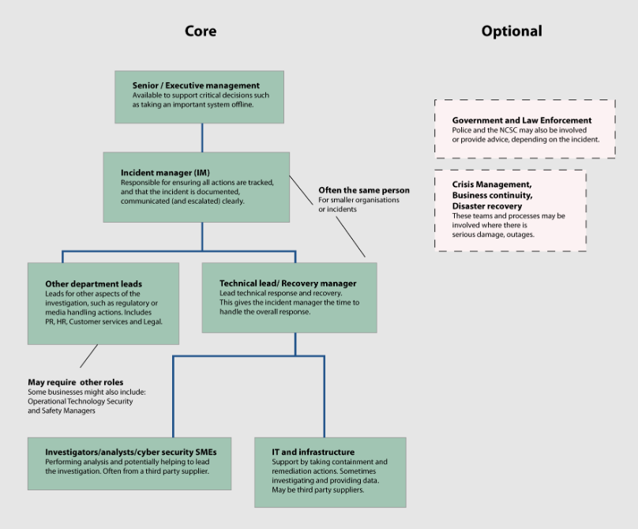
(National Cyber Security Centre, 2019)

Employee Training Coordinator
Creates and implements staff cyber security training programs to ensure all employees are trained and aware of the best security practices and policies to prevent breaches caused by human error (CybSafe, 2023).

Penetration Testers
Penetration testing is where you run a simulated attack to find and exploit vulnerabilities in Teletainment’s computer systems. Then they will provide an in-depth report and security recommendations to make the security stronger (Cloudflare, 2024).

Training and Awareness Programs

Regular Training Sessions
Mandatory cyber security training sessions for staff, focusing on modern threats and security protocols.

Security Awareness Campaigns
Run security awareness campaigns and give employees online resources, newsletters and posters such as OWASP (Open Worldwide Application Security Project) application security awareness campaigns (OWASP, 2023b).
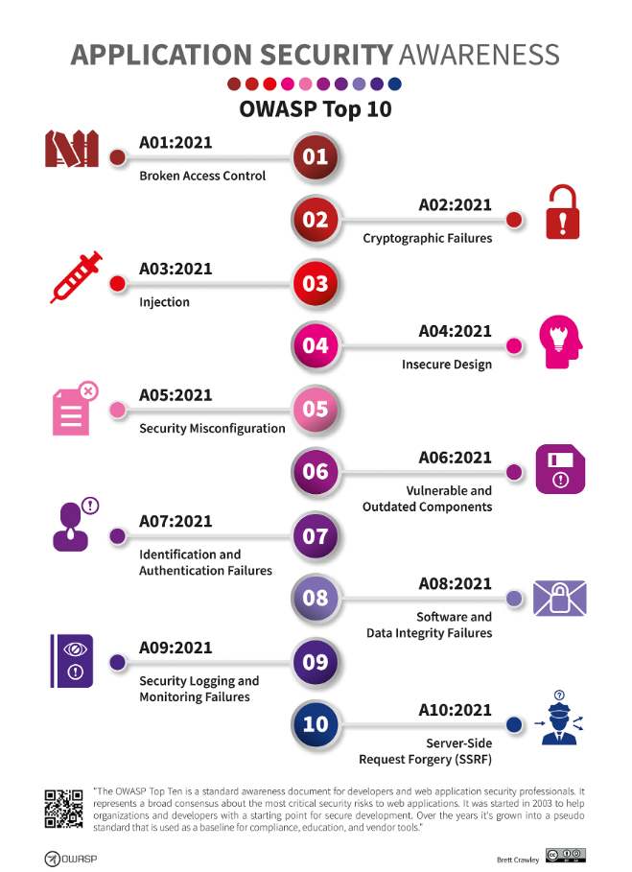
(OWASP, 2023b)

Phishing Simulations
Run weekly phishing simulations to test Teletainment’s ability to recognize and respond to a phishing attack, by having the phishing link be a landing page letting them know they failed the test and leading it to educational security awareness for phishing scams (Badman, 2023).

Incident Response Drills
Organise bi-weekly incident response drills like tabletop exercises to ensure all the team know their roles and responsibilities, also to test the effectiveness of the incident response plan.

Overall Action Plan
This section's objective is to reduce known risks, increase cyber resilience and align with frameworks such as ISO 27001 and NIST CSF. Using project management methods and cyber security standards that will guarantee a strong and effective plan designed to deliver measurable enhancements to security posture incrementally through time.

Short-term (0-6 months)

Access Control Review
Review access controls regularly, implement MFA, and ensure up-to-date password policies are followed (NCSC, 2018a).

Data Encryption Implementation:
Ensure that all encryption protocols store sensitive data in compliance with industry standards.

Incident Response Plan Development
Train the incident response team with their incident response plan that details their roles, responsibilities and communications protocols. Ensure team members are competent and can deal with security incidents properly (NCSC, 2019b).

Medium-term (6-18 months)

Regular Security Audits
Use security audits to assess security measures, identify vulnerabilities and recommend improvements (MoldStud, 2024).

Enhanced Training Programs
Training programs can be tailored to different departments to focus on emerging threats and the best practices employees should follow to mitigate the risks of an incident (Khando et al., 2021).

Disaster Recovery Drills
Test disaster recovery drills to evaluate response time, efficiency, effectiveness and potential damages and make the necessary adjustments, if necessary to improve the cyber resilience of Teletainment (Consilien, 2024).

Long-term (18+ months)

Continuous Improvement of Plans
Create a framework to constantly improve each cybersecurity plan, using the drills and audits conducted to improve and address the way Teletainment deals with evolving threats (ISMS.online, 2020).

Global Expansion Security Measures
Ensure that there are established protocols for new markets, have proper security measures in place and have compliance with the local regulations.

Advanced Threat Intelligence
Invest in threat intelligence tools to know the emerging threats and use real-time data for proactive defence and mitigations (SANS, 2024).

Assumptions and Implications
This section is for developing a strong cybersecurity strategy, identification and assessment of key presumptions about risks facing Teletainment are essential. The objective is to give a comprehensive justification for the identified assumptions and examine their implications on Teletainment’s cyber security posture as well as general business strategy.

Key Assumptions

Increased Cyber Threat Landscape
Teletainment must operate whilst dealing with constant escalating cyber threats, meaning they will need advanced security measures to protect and mitigate against frequent cyber-attacks.

Regulatory Compliance Requirements
Teletainment needs to follow regulations such as GDPR, PCI DSS and NIS. Teletainment needs to ensure compliance with these requirements as otherwise there will be legal repercussions and loss of customer trust (IT Governance, 2018a).

Costs of Teletainments Threats
The costs of how much financial damage a threat could cause is just an assumption based on Teletainment being a medium-sized company that has a T-Box which is assumed to be like a Sky Box, so I made up the asset value (AV) to make a quantitative risk assessment.

Implications of Assumptions

Proactive Security Measures
There is a need for proactive security measures, constant monitoring, quick incident response and threat intelligence to mitigate the risks to Teletainment properly (Threat Intelligence, 2023).

Technology Investment and Innovation
For Teletainment to meet the regulatory requirements and costs required to mitigate threats, there is a need to invest in cyber security to ensure that all sensitive customer information is secure.

Resilience and Continuity Planning
These assumptions show the necessity of cyber resilience and continuity planning, disaster recovery, regular testing and integrating risk assessments to maintain Teletainment’s operations constantly and stably.

Conclusion
This comprehensive cyber resilience plan will enhance Teletainment’s infrastructure, operational effectiveness and security posture. This has been achieved by using relevant compliance frameworks, analysing current resilience readiness, identifying potential threats, an overall action plan and risk assessments.
The resilience plan conducts a gap analysis of the network security, access controls, incident response and employee training to gather information on where the security gaps are and how to fix those gaps to ensure there are no future threats that can use the gaps as vulnerabilities. The short-term actions for the overall action plan are access control reviews, data encryption implementation and an incident response plan development. These actions will help provide improvements, ensuring the safety of Teletainment’s assets, quick incident response and reduce the potential of breaches.
The medium-term actions for the action plan are regular security audits, enhanced training programs and disaster recovery drills. Using regular security audits will ensure that cyber security will stay up to date, identify vulnerabilities and respond to any future threats. Enhanced training programs will teach employees to recognize and mitigate phishing and social engineering scams and other potential exploits. Disaster recovery drills test how ready Teletainment are for potential natural or cyber disasters, also ensuring that even if a disaster happens Teletainment can keep their business running continuously.
Long-term actions focus on continuously improving the cyber security and resilience of Teletainment, focusing on advanced threat intelligence systems. This proactive approach to security will assure the ability to counter and mitigate sophisticated threats and enable the ability to identify patterns predict future attacks and have effective incident response to take the damage done to a minimum.
Furthermore, the focus on regulatory compliance will protect Teletainment against legal and financial costs. Following standards and regulations like PCI DSS, ISO 27001, ISO 22301 and NIS give credibility and customers trust that Teletainment can hold sensitive data securely.
In conclusion, the resilience plan provides Teletainment with a framework to rebuild its cybersecurity. The plan ensures that it uses the best practices in the industry and achieves the business goals thereby greatly reducing ransomware attacks because security, compliance and operations are all meeting the industry’s standards.

References
Atlassian Support (2024). What are post-incident reviews? | Jira Service Management Cloud. [online] Atlassian Support. Available at: https://support.atlassian.com/jira-service-management-cloud/docs/what-are-post-incident-reviews/ [Accessed 28 Jul. 2024].
Badman, A. (2023). What is a phishing simulation? [online] IBM Blog. Available at: https://www.ibm.com/blog/phishing-simulation/ [Accessed 29 Jul. 2024].
Chin, K. (2024). How Do You Get Infected by Ransomware? | UpGuard. [online] www.upguard.com. Available at: https://www.upguard.com/blog/how-do-you-get-infected-by-ransomware [Accessed 23 Jul. 2024].
Cichonski, P., Millar, T., Grance, T. and Scarfone, K. (2012). Computer security incident handling guide. Computer Security Incident Handling Guide, [online] 2(2), pp.30–50. doi:https://doi.org/10.6028/nist.sp.800-61r2.
CISA (2024). Incident Response Plan (IRP) Basics. [online] Americas Cyber Defense Agency. Available at: https://www.cisa.gov/sites/default/files/publications/Incident-Response-Plan-Basics_508c.pdf [Accessed 28 Jul. 2024].
Cloudflare (2024). What Is Penetration Testing? What Is Pen Testing? | Cloudflare UK. Cloudflare. [online] Available at: https://www.cloudflare.com/en-gb/learning/security/glossary/what-is-penetration-testing/ [Accessed 29 Jul. 2024].
Cloudian (2024). What Is a Disaster Recovery Plan? 4 Examples. [online] Cloudian. Available at: https://cloudian.com/guides/disaster-recovery/4-disaster-recovery-plan-examples-and-10-essential-plan-items/#:~:text=In%20case%20of%20a%20physical [Accessed 28 Jul. 2024].
Consilien (2024). Disaster Recovery Drills: How to Prepare Your Team for the Unexpected. [online] Consilien | One Source | One Solution. Available at: https://www.consilien.com/news/disaster-recovery-drills-how-to-prepare-your-team-for-the-unexpected [Accessed 30 Jul. 2024].
Convocar, J.M. (2022). Common Causes of Security Gaps in Your Network & How to Resolve Them. [online] www.itsasap.com. Available at: https://www.itsasap.com/blog/how-to-resolve-security-gaps [Accessed 24 Jul. 2024].
CSRC Content Editor (2015). role-based access control (RBAC) - Glossary | CSRC. [online] Nist.gov. Available at: https://csrc.nist.gov/glossary/term/role_based_access_control [Accessed 26 Jul. 2024].
CybSafe (2023). 7 reasons why security awareness training is important | cybsafe. [online] CybSafe. Available at: https://www.cybsafe.com/blog/7-reasons-why-security-awareness-training-is-important/ [Accessed 29 Jul. 2024].
Department for Digital, Culture, Media & Sport (2021). Telecoms security: proposal for new regulations and code of practice. [online] GOV.UK. Available at: https://www.gov.uk/government/consultations/proposal-for-new-telecoms-security-regulations-and-code-of-practice/telecoms-security-proposal-for-new-regulations-and-code-of-practice [Accessed 19 Jul. 2024].
DeVry University (2023). Understanding the Chief Information Security Officer (CISO) Role in 2023. [online] devry.edu. Available at: https://www.devry.edu/blog/chief-information-security-officer-role.html [Accessed 29 Jul. 2024].
Government of UK (2018). Data Protection Act. [online] GOV.UK. Available at: https://www.gov.uk/data-protection [Accessed 19 Jul. 2024].
hackerone (2024). Advanced Persistent Threat: Attack Stages, Examples & Mitigation. [online] www.hackerone.com. Available at: https://www.hackerone.com/knowledge-center/advanced-persistent-threats-attack-stages-examples-and-mitigation [Accessed 28 Jul. 2024].
IBM (2019). What is supply chain management? [online] IBM. Available at: https://www.ibm.com/topics/supply-chain-management [Accessed 28 Jul. 2024].
IBM (2021). What Is a Security Operations Center (SOC)? | IBM. [online] www.ibm.com. Available at: https://www.ibm.com/topics/security-operations-center#:~:text=Security%20analysts%3A%20Also%20called%20security [Accessed 29 Jul. 2024].
IBM (2024). Introduction to Backup and Disaster Recovery | IBM. [online] www.ibm.com. Available at: https://www.ibm.com/topics/backup-disaster-recovery [Accessed 28 Jul. 2024].
Information Commissioner's Office (2024). Supply chain attacks. [online] ico.org.uk. Available at: https://ico.org.uk/about-the-ico/research-reports-impact-and-evaluation/research-and-reports/learning-from-the-mistakes-of-others-a-retrospective-review/supply-chain-attacks/ [Accessed 28 Jul. 2024].
Irwin, L. (2023). What Is an Insider Threat? Definition, Types, and Examples. [online] IT Governance UK Blog. Available at: https://www.itgovernance.co.uk/blog/what-is-an-insider-threat-definition-types-and-examples [Accessed 26 Jul. 2024].
ISMS.online (2020). Continual Improvement. [online] ISMS.online. Available at: https://www.isms.online/glossary/continual-improvement/ [Accessed 30 Jul. 2024].
IT Governance (2016a). Advanced Persistent Threats (APTs) | IT Governance UK. [online] Itgovernance.co.uk. Available at: https://www.itgovernance.co.uk/advanced-persistent-threats-apt [Accessed 26 Jul. 2024].
IT Governance (2016b). Essential Cyber Security - The Cyber Essentials Scheme | IT Governance UK. [online] Itgovernance.co.uk. Available at: https://www.itgovernance.co.uk/cyber-essentials-scheme [Accessed 22 Jul. 2024].
IT Governance (2016c). ISO 27001 Information Security Management | IT Governance UK. [online] Itgovernance.co.uk. Available at: https://www.itgovernance.co.uk/iso27001 [Accessed 23 Jul. 2024].
IT Governance (2016d). NIST Cybersecurity Framework (CSF). [online] Itgovernance.co.uk. Available at: https://www.itgovernance.co.uk/nist-cybersecurity-framework [Accessed 22 Jul. 2024].
IT Governance (2016e). The Data Security and Protection Toolkit (DSPT) | IT Governance Ltd. [online] Itgovernance.co.uk. Available at: https://www.itgovernance.co.uk/healthcare/dsp-toolkit [Accessed 22 Jul. 2024].
IT Governance (2016f). The NIS Directive & NIS Regulations | IT Governance UK. [online] Itgovernance.co.uk. Available at: https://www.itgovernance.co.uk/nis-directive [Accessed 19 Jul. 2024].
IT Governance (2017). ISO 22301, the international business continuity standard. [online] itgovernance.co.uk. Available at: https://www.itgovernance.co.uk/iso22301-business-continuity-standard [Accessed 23 Jul. 2024].
IT Governance (2018a). PCI DSS | IT Governance UK. [online] Itgovernance.co.uk. Available at: https://www.itgovernance.co.uk/pci_dss [Accessed 22 Jul. 2024].
IT Governance (2018b). Security Awareness Programme. [online] itgovernance.co.uk. Available at: https://www.itgovernance.co.uk/security-awareness-programme [Accessed 25 Jul. 2024].
It Governance (2018). The DPA (Data Protection Act) 2018, applied GDPR and UK derogations from the EU GDPR | IT Governance UK. [online] Itgovernance.co.uk. Available at: https://www.itgovernance.co.uk/dpa-2018 [Accessed 19 Jul. 2024].
ITGovernance (2022). IT Governance Cyber Resilience Framework (CRF) – An overview. [online] itgovernance.co.uk. Available at: https://www.itgovernance.co.uk/the-it-governance-cyber-resilience-framework [Accessed 19 Jul. 2024].
Journal of Electrical Systems (2023). Temporal Intelligence in AI-Enhanced Cyber Forensics using Time-Based Analysis for Proactive Threat Detection. Temporal Intelligence in AI-Enhanced Cyber Forensics Using Time-Based Analysis for Proactive Threat Detection, [online] 19-3(126-146), p.2. doi:https://doi.org/126-146.
Khando, K., Gao, S., Islam, S.M. and Salman, A. (2021). Enhancing employees information security awareness in private and public organisations: A systematic literature review. Computers & Security, 106(1), p.102267. doi:https://doi.org/10.1016/j.cose.2021.102267.
Lenaerts-Bergmans, B. (2022). Advanced Persistent Threats (APTs) | Definition & Examples. [online] crowdstrike.com. Available at: https://www.crowdstrike.com/cybersecurity-101/advanced-persistent-threat-apt/.
Leonardo (2020). Are you ready for the Telecoms Security Regulations? [online] uk.leonardo.com. Available at: https://uk.leonardo.com/en/news-and-stories-detail/-/detail/are-you-ready-for-telecoms-security-regulations [Accessed 23 Jul. 2024].
MoldStud (2024). The Role of Security Audits in Assessing and Strengthening Cyber Defenses. [online] moldstud.com. Available at: https://moldstud.com/articles/p-the-role-of-security-audits-in-assessing-and-strengthening-cyber-defenses#:~:text=Security%20audits%20play%20a%20pivotal [Accessed 30 Jul. 2024].
National Cyber Security Centre (2018). Principle 1: Data in transit protection. [online] www.ncsc.gov.uk. Available at: https://www.ncsc.gov.uk/collection/cloud/the-cloud-security-principles/principle-1-data-in-transit-protection [Accessed 28 Jul. 2024].
National Cyber Security Centre (2019). Build: A cyber security incident response team (CSIRT). [online] www.ncsc.gov.uk. Available at: https://www.ncsc.gov.uk/collection/incident-management/creating-incident-response-team [Accessed 29 Jul. 2024].
National Cyber Security Centre (2023). About Cyber Essentials. [online] www.ncsc.gov.uk. Available at: https://www.ncsc.gov.uk/cyberessentials/overview [Accessed 22 Jul. 2024].
NCSC (2018a). Password administration for system owners. [online] Ncsc.gov.uk. Available at: https://www.ncsc.gov.uk/collection/passwords/updating-your-approach [Accessed 30 Jul. 2024].
NCSC (2018b). Supply chain security guidance. [online] www.ncsc.gov.uk. Available at: https://www.ncsc.gov.uk/collection/supply-chain-security [Accessed 26 Jul. 2024].
NCSC (2019a). General Data Protection Regulation (GDPR). [online] Ncsc.gov.uk. Available at: https://www.ncsc.gov.uk/information/GDPR [Accessed 22 Jul. 2024].
NCSC (2019b). Plan: Your cyber incident response processes. [online] Ncsc.gov.uk. Available at: https://www.ncsc.gov.uk/collection/incident-management/cyber-incident-response-processes [Accessed 30 Jul. 2024].
NCSC (2020). Exercise in a Box. [online] Ncsc.gov.uk. Available at: https://www.ncsc.gov.uk/information/exercise-in-a-box [Accessed 25 Jul. 2024].
NCSC (2021). NCSC’s new cyber security training for staff now available. [online] www.ncsc.gov.uk. Available at: https://www.ncsc.gov.uk/blog-post/ncsc-cyber-security-training-for-staff-now-available [Accessed 25 Jul. 2024].
NCSC (2022). Understanding the threat. [online] www.ncsc.gov.uk. Available at: https://www.ncsc.gov.uk/collection/assess-supply-chain-cyber-security/understanding-the-threat [Accessed 26 Jul. 2024].
NCSC (2023a). Ransomware, extortion and the cyber crime ecosystem. [online] www.ncsc.gov.uk. Available at: https://www.ncsc.gov.uk/whitepaper/ransomware-extortion-and-the-cyber-crime-ecosystem [Accessed 23 Jul. 2024].
NCSC (2023b). The fundamentals and basics of cyber risk. [online] www.ncsc.gov.uk. Available at: https://www.ncsc.gov.uk/collection/risk-management/the-fundamentals-and-basics-of-cyber-risk [Accessed 26 Jul. 2024].
NCSC (2024). Principle B2 Identity and Access Control. [online] Ncsc.gov.uk. Available at: https://www.ncsc.gov.uk/collection/cyber-assessment-framework/caf-objective-b/principle-b2-identity-and-access-control [Accessed 24 Jul. 2024].
nibusinessinfo (2023). Compliance and regulatory risk | nibusinessinfo.co.uk. [online] www.nibusinessinfo.co.uk. Available at: https://www.nibusinessinfo.co.uk/content/compliance-and-regulatory-risk#:~:text=While%20regulatory%20risk%20relates%20to [Accessed 28 Jul. 2024].
NIST (2022). Assessing Security and Privacy Controls in Information Systems and Organizations. NIST.SP.800-53, 800-137(800-53Ar5), p.87. doi:https://doi.org/10.6028/nist.sp.800-53ar5.
NIST (2024a). The NIST Cybersecurity Framework (CSF) 2.0. The NIST Cybersecurity Framework (CSF) 2.0, [online] 2.0(29), pp.8–10. doi:https://doi.org/10.6028/nist.cswp.29.
NIST (2024b). The NIST Cybersecurity Framework (CSF) 2.0. The NIST Cybersecurity Framework (CSF) 2.0, [online] 2.0(29), p.20. doi:https://doi.org/10.6028/nist.cswp.29.
Nizami, M. (2024). Incident Response Team | Roles & Responsibilities Defined. [online] www.blameless.com. Available at: https://www.blameless.com/blog/incident-response-team-roles-responsibilities-defined [Accessed 28 Jul. 2024].
O’Connor, N. (2023). Why you need a customer support operations team. [online] The Intercom Blog. Available at: https://www.intercom.com/blog/why-you-need-a-customer-support-operations-team/ [Accessed 28 Jul. 2024].
OWASP (2023a). M10: Insufficient Cryptography | OWASP Foundation. [online] owasp.org. Available at: https://owasp.org/www-project-mobile-top-10/2023-risks/m10-insufficient-cryptography#:~:text=This%20can%20result%20in%20a [Accessed 24 Jul. 2024].
OWASP (2023b). OWASP Application Security Awareness Campaigns | OWASP Foundation. [online] owasp.org. Available at: https://owasp.org/www-project-application-security-awareness-campaigns/ [Accessed 29 Jul. 2024].
PacketLabs (2021). What is Network Segmentation and can it help with Ransomware? [online] Packetlabs. Available at: https://www.packetlabs.net/posts/network-segmentation/#:~:text=Without%20network%20segmentation%2C%20an%20attacker [Accessed 24 Jul. 2024].
Poremba, S. (2023). What Does a Network Security Engineer Do? [online] Security Intelligence. Available at: https://securityintelligence.com/articles/what-does-a-network-security-engineer-do/ [Accessed 29 Jul. 2024].
SANS (2024). The Importance of Cyber Threat Intelligence: Insights from Recent Nobelium Attacks. [online] www.sans.org. Available at: https://www.sans.org/blog/the-importance-of-cyber-threat-intelligence-insights-from-recent-nobelium-attacks/ [Accessed 30 Jul. 2024].
SecurityScorecard (2023). Qualitative vs. Quantitative Cybersecurity Risk Assessment. [online] SecurityScorecard. Available at: https://securityscorecard.com/blog/qualitative-vs-quantitative-risk-assessment/#:~:text=Quantitative%20risk%20assessments%20provide%20actionable [Accessed 28 Jul. 2024].
Sharron, M. (2020). ISO 22301, The Business Continuity Management Standard. [online] ISMS.online. Available at: https://www.isms.online/iso-22301/ [Accessed 23 Jul. 2024].
Spitzner, L. (2021). SANS Security Awareness | Reduce Risk with Strong Secure Passwords. [online] www.sans.org. Available at: https://www.sans.org/blog/strong-secure-passwords-are-key-to-helping-reduce-risk-to-your-organization/ [Accessed 24 Jul. 2024].
Threat Intelligence (2023). Proactive Cybersecurity - What Is It, and Why You Need It. [online] www.threatintelligence.com. Available at: https://www.threatintelligence.com/blog/proactive-cybersecurity [Accessed 30 Jul. 2024].
Verizon (2023). DBIR 2023 Data Breach Investigations Report. [online] pp.35–36. Available at: https://www.verizon.com/business/resources/Te68/reports/2023-data-breach-investigations-report-dbir.pdf [Accessed 24 Jul. 2024].
Viostream (2022). How Can Internal And External Communications Work Together? [online] www.viostream.com. Available at: https://www.viostream.com/blog/internal-and-external-communications-together [Accessed 28 Jul. 2024].

